Our mission is to provide information services to connect with the people of NW Alaska and improve their quality of life

2018 LOCAL CONTENT AND SERVICE
REPORT TO THE COMMUNITY
LOCAL VALUE

KOTZ-AM is a valuable part of the NW Alaska’s advancement.

The station airs meeting announcements for all public meetings.

The station carries interviews with all federal, state and local entities that hold public meetings in the region.

The outcome of these meetings can affect subsistence, safety, education and health issues that are critical to local residents.

“

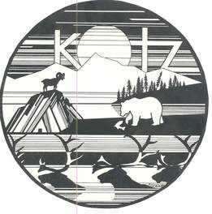
LOCAL IMPACT

2018 KEY
SERVICES

In 2018, KOTZ-AM provided these vital local services:
Emergency Alert System participation
Live weekly reports from the
- NW Arctic School District
- NW Arctic Borough
- US Coast Guard
- National Parks Ser.
Live coverage of the NW Arctic Assembly Meetings
Search and Rescue Information
Weather and fishing information
Coverage of local sports:
- Local HS Basketball
- Dog races

KOTZ’s local services had deep impact in NW Alaska

KOTZ is considered critical infrastructure in NW Alaska.

The villages in the region and especially remote camps depend upon the station for critical weather, news and public affairs programming that has an impact on their lives.

There is no daily newspaper in the region so to find out about current events the station is the best source of local information.

2018 LOCAL CONTENT AND SERVICE REPORT
IN THE COMMUNITY

KOTZ-720 AM has been a critical part of the community and the region since 1973 when it first came on the air. Communications in 1973 consisted of a single VHF phone in the villages in NW Alaska. People would wait in long lines to make a call on that phone. When people in the villages wanted to contact someone else in the region, they couldn’t count on being able to reach someone in the next village by calling that village, they would instead call KOTZ and put a message on Tundra Telegraph. That relationship with our listeners has continued for 45 years.
KOTZ provides local, state and national news, local weather, public affairs and entertainment. KOTZ provides critical weather and search and rescue information and is the primary Emergency Alert System originator for the region.
One of the most listened to programs is high school basketball coverage. Local sports play a big part of the coverage the station offers. Dog races both sprint and long distance with the Kobuk 440 being the major race along with a 250-mile snow machine race both draw racers from across the state.

KOTZ is a member station of Alaska Public Media and National Public Radio.
KOTZ also carries a number of Native language programs that add to the culture and traditions of the Inupiat people of NW Alaska. We work with the IRA and the village and regional Native corporations to promote cultural awareness. We respond to issues that affect the residents of the NW Arctic Borough and rural Alaska. Our goal is to provide a public forum for the discussion of issues that affect our listeners. To educate and inform and provide the opportunity for public access is an important part of who we are.
Kotzebue Broadcasting, Inc. is a non-profit Native American controlled public broadcasting corporation that also operates a FM radio station located in Kotzebue, Alaska. Kotzebue Broadcasting, Inc is a 501c (3) non-profit corporation.
In 2009, KOTZ 90.3 FM signed on the air as a second service providing an alternative, more localized, program stream to Kotzebue with a 1Kilowatt low power analog transmitter. 89.9 FM. The Mix offers an all music format with local meetings and sports. Coordinating with public media organizations in the Alaska we also broadcast ARCS (Alaska Rural Communication Service) a local on-air television service that carries network programming.
KOTZ radio serves a population of approximately 8,000 predominantly Inupiat residents in the NW Alaska. KOTZ-AM is the only radio station available for most of that population.
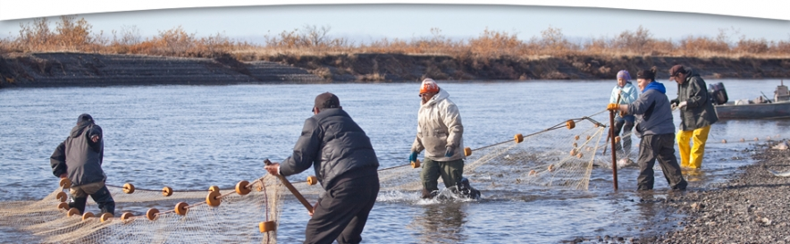
2018 LOCAL CONTENT AND SERVICE REPORT
STORIES OF IMPACT
Supporting Search and Rescue Efforts

KOTZ supports a remote population in a working marine and Arctic environment that depends heavily on emergency alert and severe weather information.
Every year there are a number of search efforts to find residents that have become stranded in bad weather a blizzard or may have had an equipment breakdown. We help mobilize the population with announcements and official reports.

Supporting Job Training Efforts

Than Alaska Technical Center (ATC) staff are regular visitors to the station and we have both staff and students on the air to discuss available training.
The ATC is the primary training school for mill wrights for the Red-Dog mine, which is the second largest zinc mine in the world. They also train Certified Nurse Aides for the local hospital as well as food service and construction skill training.

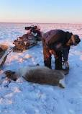

Supporting Subsistence Efforts

Subsistence is an issue that is important to the entire region. We regularly air interviews with all of the agencies that have an impact on the issue. Including the National park Service, Alaska Department of Fish and Game, US Fish and Wildlife just to name a few.

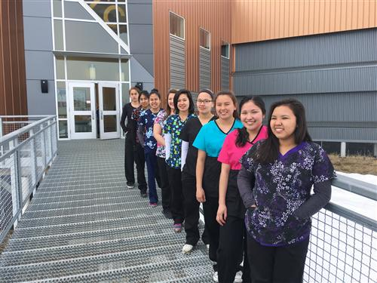
2018 LOCAL CONTENT AND SERVICE REPORT
STORIES OF IMPACT

Regional Communication Needs

KOTZ General Manager has regular meetings to discuss the communication needs of the borough and the 10 communities affected. Updates on station emergency broadcast plans are a topic covered.

Reach in the Community:

KOTZ’s s General Manager and Program Director met with local educators to increase promotion of school activities and to enhance and develop student journalism opportunities.

Partnerships:

KOTZ’ works closely with the NW Arctic Borough, the city of Kotzebue, local and regional Native corporations and local business partners to develop and discuss the communication needs of the listening area.

Impact and Community Feedback:

The community has expressed gratitude for news coverage of council, and assembly meetings, sports activities and educational programming. That support is expressed with fundraising that equals $12.50 per resident.

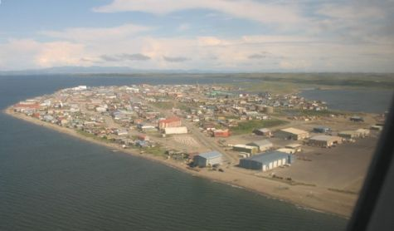

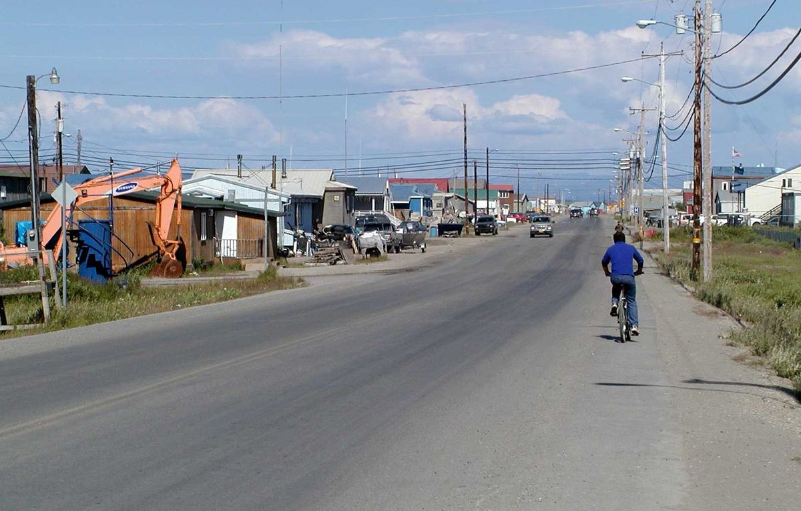
2018 LOCAL CONTENT AND SERVICE REPORT
SUMMARY

“KOTZ remains a vital part of our community. When I need to know about current events the station is where I turn for current information.

Matt Bergan - Kotzebue Electric Association Engineer
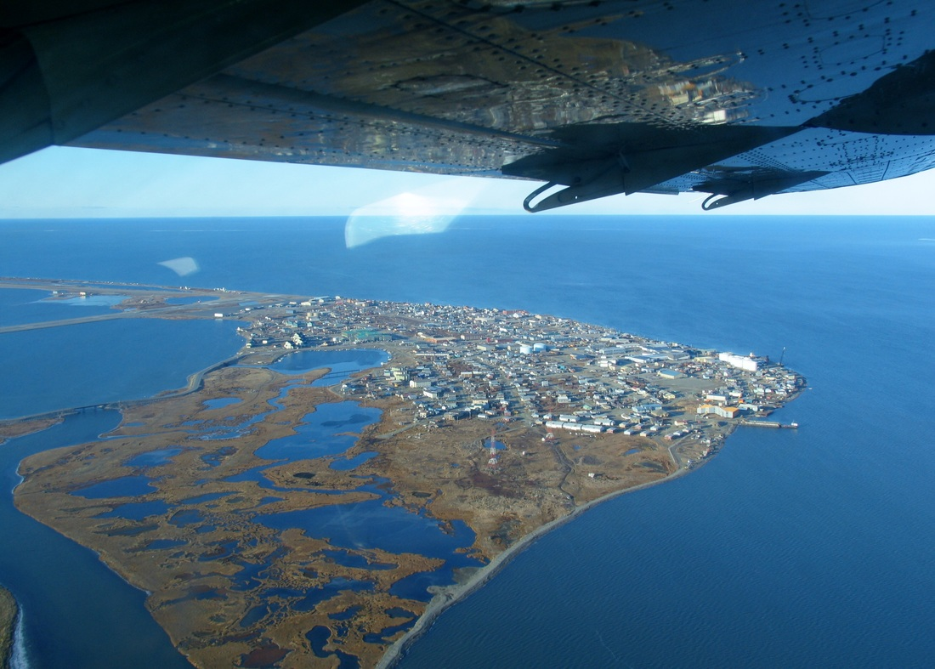
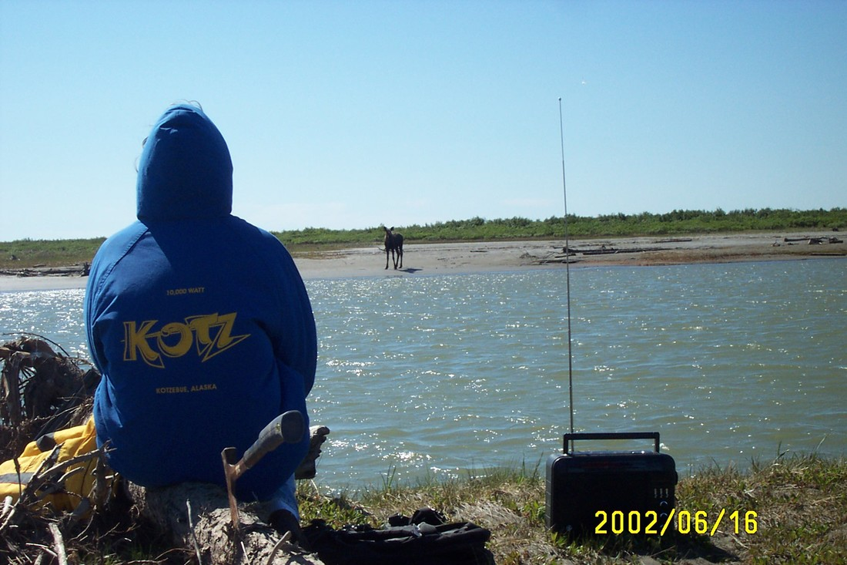

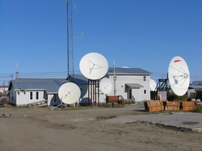

View of the station studio and all of the satellite dishes that bring state and national news, public affairs and entertainment programming to the station and the region.

KOTZ continues to be the link to the world, state and region for the residents of the NW Arctic Borough. The station has been a trusted source of local and public affairs programming for the region. The station is the source for live coverage of important meetings and events throughout the region that have an impact on our listeners

